## Executive Summary

A detailed examination of BMR Resort(BMR) facilities in comparison to all other ski resorts in the US has BMR at a competitive position in the market on multiple fronts. The concern that current ski ticket prices already are at a premium and cannot be raised further is not true when BMR is being sized up relative to other ski resorts outside of Montana. Also, based on the numbers, there is room to implement operational efficiencies by closure of some facilities while still increasing profits. If we are picking the easiest variable to change, then implementing ticket price increases should be prioritized over operational cost reductions.

## Pricing Analysis Details

BMR does charge a premium in relation to other ski facilities located in Montana, but when compared with ski resorts nationwide, BMR provides a lot of value for their ticket price. Based on the facilities provided, the weekend ticket price could be increased to an average of $96. This average still accounts for an MAE of $10. BMR currently charges $81 for their ticket, so even assuming our model is very wrong, there is still a safe $5 gap in ticket price if both weekday and weekend prices were raised by $5.

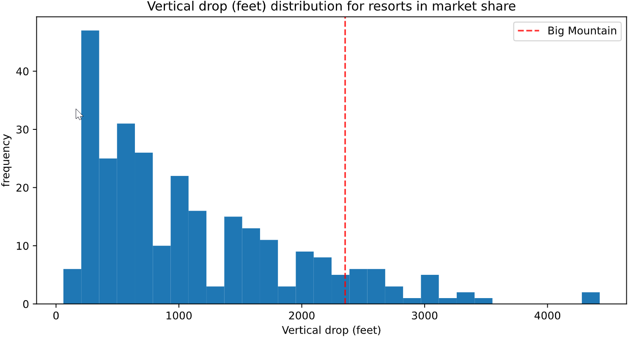 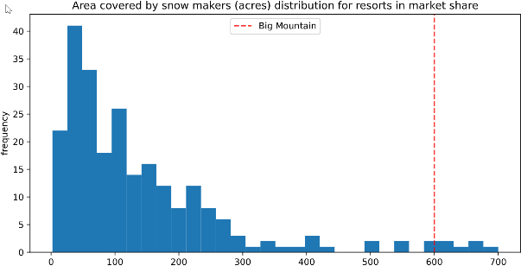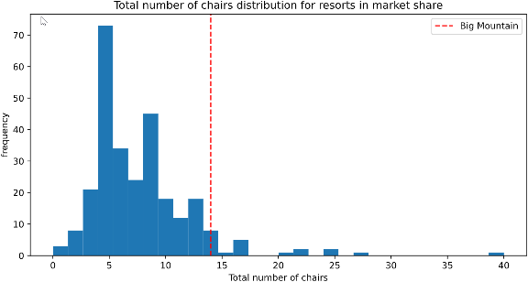 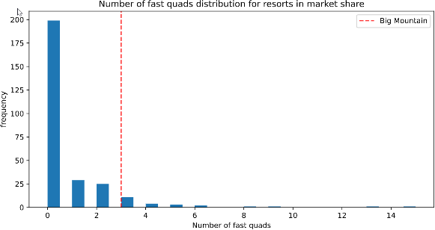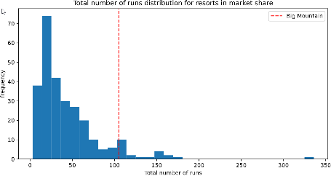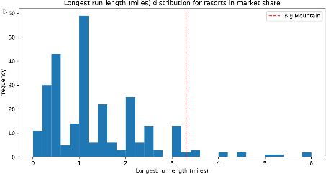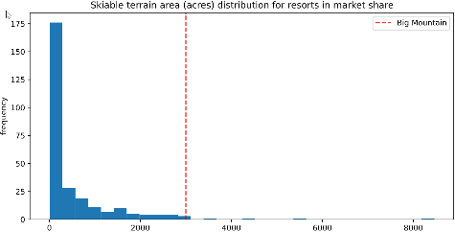

### Weekday & Weekend Prices

Curiously, in Montana, all ski resorts charge the same for weekday and weekend prices. If there is a huge concern in prices increases affecting visitor count, it is possible to implement different prices for weekday and weekend ski days. This would be normal if we compared this pricing model across the US. 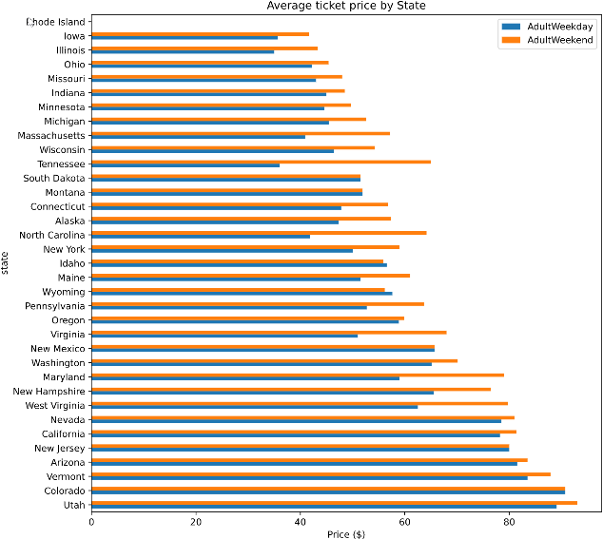 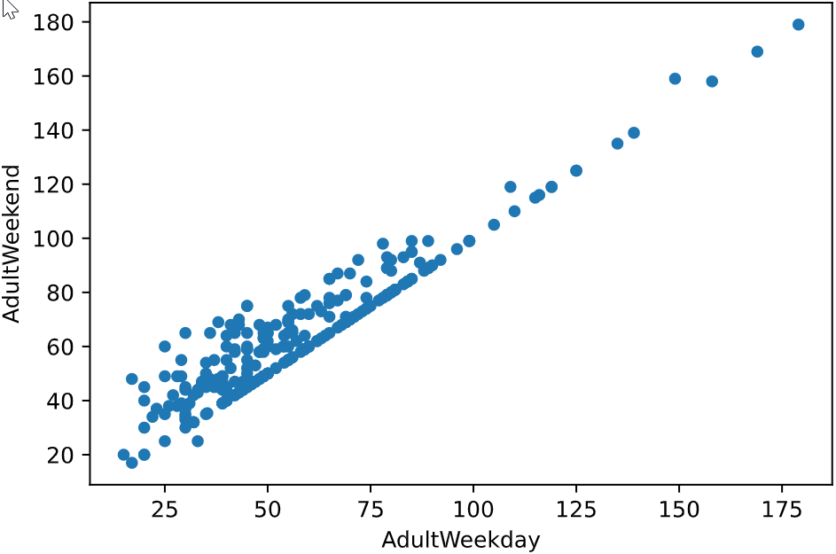

## Features Affecting Ticket Price by Magnitude of Importance

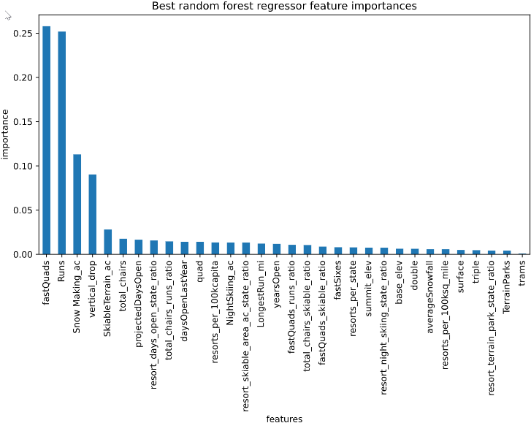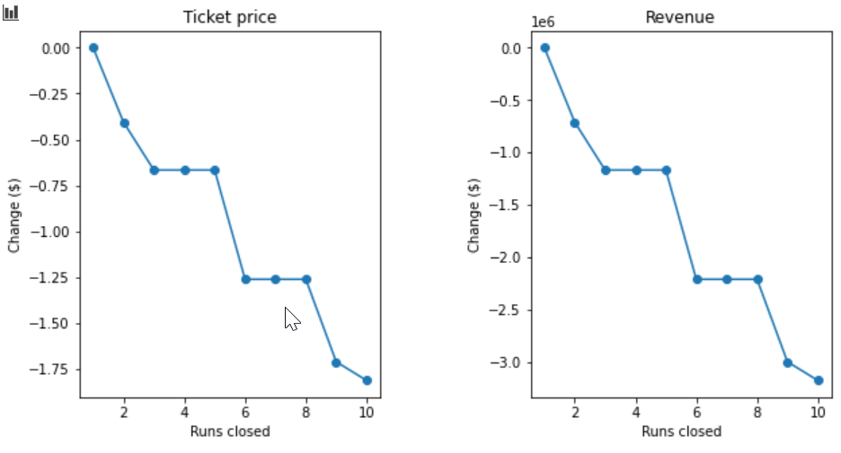

If the goal of attaining more profitability through cost savings, models are predicting some loss of revenue, but because BMR is already the leader in many ski resort feature categories it’s possible the models might be overstating the impact to ski prices.

## Conclusion

BMR can experiment with raising overall ticket prices or cost reduction measures in order to raise overall profits. Both methods of generating more profits are available because BMR’s ticket price overall still provides a lot of value overall in comparison to other ski resorts.

## Future Areas of Exploration

The dataset provides information to compare ticket prices in relation to ski feature in general. One very helpful data would be the average number of visitors for each of the ski resorts. Another piece of data missing is the ratio of out of town and out of state visitors. Our data analysis focused on BMR in relation to the US, but if BMR’s visitors are local, there is justification that ticket price increases will face greater resistance.